**EXPERIMENT NO. 6**

**TITLE :**To demonstrate various DOS commands (2).

**OBJECTIVE :**

* To learn about command prompt.
* To learn various commands of dos.

**THEORY :**

A DOS, or disk operating system, is an operating system that runs from a disk drive. The term can also refer to a particular family of disk operating systems, most commonly [MS-DOS](https://www.techtarget.com/searchenterprisedesktop/definition/MS-DOS).

**What Are MS-Dos Commands?**

MS-DOS is a text-based system of Microsoft Operating System, The users interact with the computer by typing text-based commands rather than a Graphical User Interface. These commands allow users to perform various tasks, such as copying, deleting, or moving files, and managing programs.

|  |  |  |
| --- | --- | --- |
| **Command** | **Syntax** | **Description** |
| CD | CD [drive:][path]Change | gets the current directory to the specified folder. |
| DIR | DIR [drive:][path] | Displays a list of files in a directory. |
| COPY | COPY [destination] | Copies files from one location to another. |
| DEL | DEL [drive:][path] | Deletes one or more files. |
| REN | REN[name] [new_name] | Renames a file or directory. |
| MKDIR | MKDIR [drive:][path] | Creates a new directory. |
| RMDIR | RMDIR [drive:][path] | Removes an existing directory. |
| COPY CON | COPY CON [file_name] | Creates text files or batch files |
| MOVE | MOVE [file] [destination] | To move the file from one directory to another. |
| TREE | TREE [drive:][path] | Displays the folder structure of a drive or path. |
| EXIT | EXIT | Exits the MS-DOS command prompt or a batch file. |
| COLOR | COLOR [code] | To change the color of command’s text. |

**DEMONSTRATION :**

* 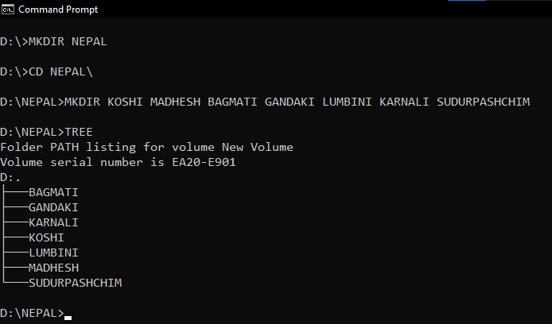Creating directories using **MKDIR** command.

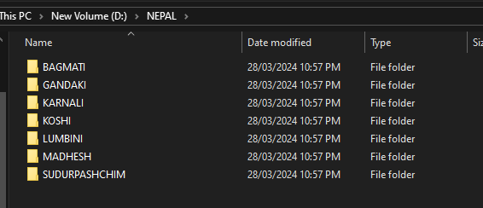

* 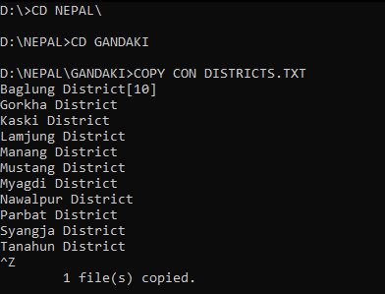Creating files using **COPY CON** command

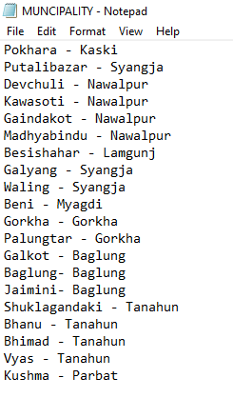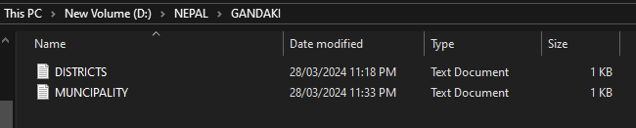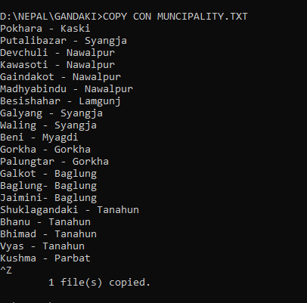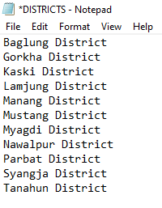

* 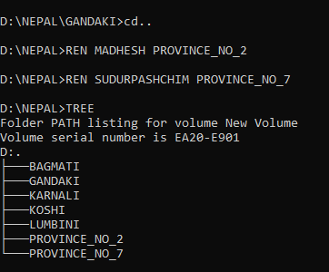Renaming directory using **REN** command
* Remove directory using **RMDIR** command

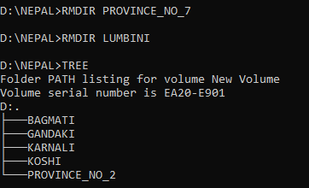

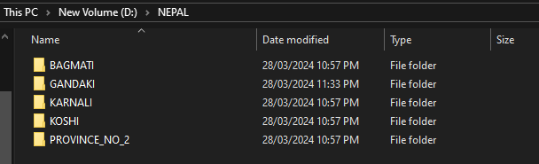

* 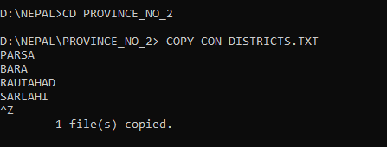Delete files using **DEL** command.

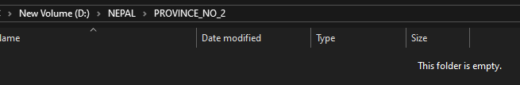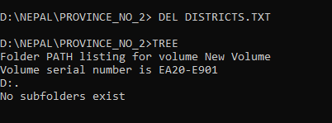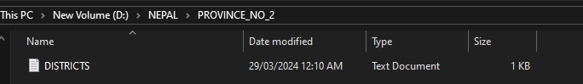

* 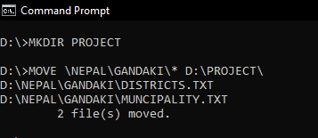Moving files using **MOVE** command.

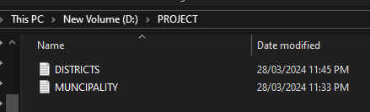

* Changing text color using **COLOR** command.

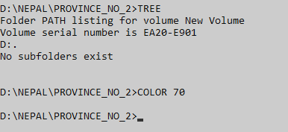

**CONCLUSION :**

This laboratory exercise provided a hands-on experience in various DOS command. Creating new directories and files using ms-dos and editing them with commands. After completing the lab experiment, students gained the practical knowledge of the ms-dos.